REQUIREMENTS ANALYSIS DOCUMENT
for
Smart Personal Task Manager

1.0
01.11.2025

Prepared by
Yavuz Selman Haltaş
Ünal Sarıemir
Yusuf Alperen Dönmez
Emre Can Tuncer
Alperen Özdelen

TABLE OF CONTENTS
1 Introduction 3
1.1 Purpose of the system 3
1.2 Scope of the system 3
1.3 Objectives and success criteria of the project 3
1.4 Definitions, acronyms, and abbreviations 3
1.5 References 3
1.6 Overview 3
2 Current system 3
3 Proposed system 3
3.1 Overview 3
3.2 Functional requirements 3
3.3 Nonfunctional requirements 4
3.3.1 Usability 4
3.3.2 Reliability 4
3.3.3 Performance 4
3.3.4 Supportability 4
3.3.5 Implementation 4
3.3.6 Interface 4
3.3.7 Packaging 4
3.3.8 Legal 4
3.4 System models 4
3.4.1 Scenarios 4
3.4.2 Use case model 4
3.4.3 Object model 4
3.4.4 Dynamic model 4
3.4.5 User interface 5
4 Glossary 5

Introduction

Purpose of the system

Scope of the system

Objectives and success criteria of the project

Definitions, acronyms, and abbreviations

References

Overview

Current system

Proposed system

Overview

Functional requirements

Nonfunctional requirements

Usability

Reliability

Performance

Supportability

Implementation

Interface

Packaging

Legal

System models

Scenarios

Use case model

Object model

Dynamic model

User interfaces and Mock-ups

Glossary of Terms

Traceability

1. Introduction
1.1 Purpose of the system
The Smart Personal Task Manager is a web application designed to make traditional to-do lists into a dynamic system by the Franklin Covey methodology. The system enables users to manage tasks with advanced features including priority categorization, context tagging, recurring task automation, and visual timeline management. The application aims to elevate personal and professional productivity by providing intelligent task organization and timely reminders.
1.2 Scope of the system
- User authentication and profile management
- Project-based task organization with hierarchical structure
- Task creation with multiple attributes (deadline, priority A/B/C/D, context, recurrence pattern)
- Support for both one-time and recurring tasks with flexible scheduling
- Calendar-based visualization with multiple view modes (daily, weekly, monthly)
- Intelligent reminder system with configurable notification methods (email, popup)
- Task filtering, sorting, and search functionality
- Data persistence using PostgreSQL database
1.3 Objectives and success criteria of the project
1.3.1 Project objectives:
- Implement a fully functional task management system demonstrating advanced OOP principles
- Deliver a user-friendly interface that simplifies complex task organization
- Demonstrate proficiency in full-stack development using Java Spring Boot, React, and PostgreSQL
- Apply design patterns (Strategy, Observer, Factory) appropriately throughout the system
- Create comprehensive UML documentation reflecting system architecture
1.3.2 Success Criteria:
- Users can create, read, update, and delete projects and tasks with less than 2 seconds response time
- Recurring task scheduling works accurately for daily, weekly, and monthly patterns
- Reminder notifications are delivered within 1 minute of scheduled time
- System supports minimum 50 concurrent users without performance degradation
- Calendar views render correctly across major browsers (Chrome, Firefox, Safari, Edge)
- User data persists reliably with zero data loss scenarios

1.4 Definitons, acronyms, and abbreviations

Term | Definition
API | Application Programming Interface
CRUD | Create, Read, Update, Delete
DTO | Data Transfer Object
Franklin Covey | Time management methodology emphasizing priority-based task organization
OOP | Object-Oriented Programming
ORM | Object-Relational Mapping
REST | Representational State Transfer
SPA | Single Page Application
UML | Unified Modeling Language
Priority A | Critical/urgent tasks requiring immediate attention
Priority B | Important tasks with scheduled deadlines

1.5 References
- Object-Oriented Software Engineering, Using UML, Patterns, and Java, 3rd Edition, by Bernd Bruegge and Allen H. Dutoit, Prentice-Hall, 2010, ISBN 10: 0136066836.
- Spring Boot Documentation: https://spring.io/projects/spring-boot
- React.js Documentation: https://react.dev/
- PostgreSQL Documentation: https://www.postgresql.org/docs/
- Manage Your Time and Energy Effectively, by Franklin Covey
1.6 Overview
This document provides a comprehensive analysis of requirements for the Smart Personal Task Manager system. Section 2 describes current task management practices and their limitations. Section 3 details the proposed system, including functional and nonfunctional requirements, supported by UML models illustrating system architecture and behavior. Section 4 provides a glossary of domain-specific terms, and Section 5 establishes traceability between requirements and design elements.
2. Current System
Currently, users manage personal and professional tasks through various fragmented approaches:
Existing Methods:
- Physical Planners and Notebooks:
- Users write tasks in paper planners using basic to-do lists
- Manual priority marking and deadline tracking
- No automated reminders or recurring task support
- Risk of loss and no backup mechanism
- Basic Digital To-Do Lists:
- Simple applications like Apple Reminders, Google Keep, or Todoist
- Limited organizational structure beyond basic lists
- Minimal priority categorization
- Weak context-based filtering
- Spreadsheets:
- Excel or Google Sheets used for task tracking
- Manual entry and updating required
- No automated notifications
- Difficult to visualize timelines
Problems With the Current System:
- Lack of Integration: Task information scattered across multiple tools and platforms
- No Intelligent Scheduling: Recurring tasks require manual recreation
- Poor Visualization: Difficult to see task distribution across time periods
- Inconsistent Prioritization: No standardized priority framework
- Missing Notifications: Users must remember to check tasks regularly
- Limited Context Awareness: Cannot filter tasks by location or situation
- No Project Hierarchy: Tasks cannot be grouped under larger projects
- Accessibility Issues: Data not accessible across devices seamlessly
- Manual Overhead: Repetitive administrative tasks consume productive time
- No Analytics: Cannot track completion rates or identify bottlenecks
3. Proposed System
3.1 Overview
The Smart Personal Task Manager is a full-stack web application that provides comprehensive task and project management capabilities. Built using modern technologies (Java Spring Boot backend, React frontend, PostgreSQL database), the system implements the Franklin Covey methodology through an intuitive interface.
Key Features:
- Project-Based Organization: Tasks organized within projects for better structure
- Advanced Task Attributes: Deadlines, four-tier priorities (A/B/C/D), context tags
- Flexible Scheduling: Support for one-time and recurring tasks (daily/weekly/monthly)
- Visual Timeline: Multiple calendar views (daily, weekly, monthly) using Strategy pattern
- Smart Reminders: Observer-pattern based notifications via email and popup
- Persistent Storage: PostgreSQL database ensuring data reliability
- RESTful Architecture: Clean API design enabling future mobile integration
- Responsive Design: Seamless experience across desktop and tablet devices
Architecture Overview:
- Frontend: React.js
- Backend: Spring Boot RESTful API with layered architecture
- Database: PostgreSQL
- Authentication: JWT-based security
- Notifications: Spring Email and WebSocket for real-time updates
3.2 Functional Requirements
User Management Module:
FR-1: The system shall allow users to register with email, username, and password.
FR-2: The system shall authenticate users using email and password credentials.
FR-3: The system shall provide password reset functionality via email verification.
FR-4: The system shall allow users to update their profile information including name, email, and notification preferences.
FR-5: The system shall enable users to change their password after authentication.
FR-6: The system shall maintain user session using JWT tokens with 24-hour expiration.

Project Management Module:
FR-7: The system shall allow users to create projects with name, description, and color code.
FR-8: The system shall enable users to view all their projects in a list or grid layout.
FR-9: The system shall allow users to update project details including name, description, and color.
FR-10: The system shall permit users to delete projects and provide warning about contained tasks.
FR-11: The system shall support archiving projects without deleting associated tasks.
FR-12: The system shall display project completion percentage based on completed tasks.

Task Management Module:
FR-13: The system shall allow users to create one-time tasks with title, description, due date, priority (A/B/C/D), and context tags.
FR-14: The system shall enable users to create recurring tasks with all one-time task attributes plus recurrence pattern (daily, weekly, monthly, custom).
FR-15: The system shall automatically generate task instances for recurring tasks based on defined patterns.
FR-16: The system shall allow users to edit task details including title, description, deadline, priority, and context.
FR-17: The system shall permit users to mark tasks as complete with timestamp recording.
FR-18: The system shall allow users to delete individual tasks.
FR-19: The system shall support task status transitions: Not Started, In Progress, Completed, Deferred.
FR-20: The system shall enable users to assign tasks to specific projects.
FR-21: The system shall allow users to add multiple context tags to tasks (@home, @office, @phone, @errands, custom).
FR-22: The system shall support task notes and comments for additional details.
FR-23: The system shall allow users to set task duration estimates.
FR-24: The system shall enable modification of individual recurring task instances without affecting future occurrences.
FR-25: The system shall allow users to skip specific occurrences of recurring tasks.

Calendar and Visualization Module
FR-26: The system shall display tasks in a daily calendar view showing all tasks for selected date.
FR-27: The system shall display tasks in a weekly calendar view showing seven consecutive days.
FR-28: The system shall display tasks in a monthly calendar view showing all days of selected month.
FR-29: The system shall allow users to switch between daily, weekly, and monthly calendar views.
FR-30: The system shall highlight today's date in all calendar views.
FR-31: The system shall display task priority through color coding in calendar views.
FR-32: The system shall show task completion status visually in calendar views.
FR-33: The system shall enable users to navigate forward and backward through calendar views.
FR-34: The system shall allow users to jump to specific dates via date picker.
FR-35: The system shall display task count per day in monthly view.

Reminder and Notification Module:
FR-36: The system shall send email reminders for tasks based on user-configured lead time (1 hour, 1 day, 1 week before due date).
FR-37: The system shall display popup notifications in-application for upcoming tasks.
FR-38: The system shall allow users to configure notification preferences per task.
FR-39: The system shall send notifications for overdue tasks daily until completion.
FR-40: The system shall provide notification history showing all sent reminders.
FR-41: The system shall allow users to snooze notifications for configurable durations.
FR-42: The system shall support multiple simultaneous reminder times for single task.

Search and Filter Module:
FR-43: The system shall allow users to search tasks by title and description using keyword matching.
FR-44: The system shall enable filtering tasks by priority level (A, B, C, D).
FR-45: The system shall support filtering tasks by status (Not Started, In Progress, Completed, Deferred).
FR-46: The system shall allow filtering tasks by context tags.
FR-47: The system shall enable filtering tasks by project.
FR-48: The system shall support filtering tasks by date range.
FR-49: The system shall allow combination of multiple filters simultaneously.
FR-50: The system shall provide sorting options for tasks (by due date, priority, creation date, title).
FR-51: The system shall display search and filter results in real-time as criteria change.

Reporting and Analytics Module:
FR-52: The system shall generate completion rate statistics per project.
FR-53: The system shall display task distribution charts by priority level.
FR-54: The system shall show productivity trends over time (daily, weekly, monthly completion rates).
FR-55: The system shall identify and display overdue tasks count.
FR-56: The system shall provide task completion history with timestamps.

Data Management Module:
FR-57: The system shall automatically save all user data to PostgreSQL database in real-time.
FR-58: The system shall provide data export functionality in JSON format.
FR-59: The system shall support data import from JSON files.
FR-60: The system shall maintain audit trail for all task modifications with user and timestamp.

3.3 Nonfunctional Requirements

3.3.1 Usability
NFR-1: The system shall provide an intuitive user interface requiring no training for basic task operations.
NFR-2: The system shall respond to user actions with visual feedback within 200 milliseconds.
NFR-3: The system shall use consistent color coding across all views for priority levels (Red: A, Orange: B, Yellow: C, Green: D).
NFR-4: The system shall provide helpful error messages guiding users to resolution.
NFR-5: The system shall support keyboard shortcuts for common operations (Ctrl+N: new task, Ctrl+S: save, Ctrl+F: search).
NFR-6: The system shall maintain user preferences across sessions.
NFR-7: The system shall provide contextual help tooltips on all input fields.
NFR-8: The system shall support undo operation for task deletion within 5 seconds.

3.3.2 Reliability
NFR-9: The system shall maintain 99.5% uptime during business hours (6 AM - 10 PM).
NFR-10: The system shall automatically recover from database connection failures within 30 seconds.
NFR-11: The system shall perform database backups daily at 2 AM.
NFR-12: The system shall validate all user inputs to prevent data corruption.
NFR-13: The system shall handle concurrent user operations without data loss.
NFR-14: The system shall log all errors with stack traces for debugging.
NFR-15: The system shall provide transaction rollback for failed operations.

3.3.3 Performance
NFR-16: The system shall load initial dashboard within 3 seconds on standard broadband connection.
NFR-17: The system shall render calendar views with up to 1000 tasks within 2 seconds.
NFR-18: The system shall perform search operations and return results within 1 second.
NFR-19: The system shall support minimum 50 concurrent users without performance degradation.
NFR-20: The system shall complete database queries within 500 milliseconds for 95% of operations.
NFR-21: The system shall process recurring task generation for 100 tasks within 5 seconds.
NFR-22: The system shall send email notifications within 1 minute of trigger time.

3.3.4 Supportability
NFR-23: The system shall maintain comprehensive API documentation using Swagger/OpenAPI.
NFR-24: The system shall use structured logging with severity levels (DEBUG, INFO, WARN, ERROR).
NFR-25: The system shall provide administrator dashboard for system health monitoring.
NFR-26: The system shall support database migration scripts for version updates.
NFR-27: The system shall maintain modular architecture allowing component updates without full system restart.
NFR-28: The system code shall maintain minimum 80% test coverage.

3.3.5 Implementation
NFR-29: The system shall be implemented using Java 17 and Spring Boot 3.x framework.
NFR-30: The system frontend shall be developed using React 18.x with TypeScript.
NFR-31: The system shall use PostgreSQL 15.x for data persistence.
NFR-32: The system shall implement RESTful API following OpenAPI 3.0 specification.
NFR-33: The system shall use Hibernate/JPA for object-relational mapping.
NFR-34: The system shall implement JWT-based authentication.
NFR-35: The system shall use Maven for dependency management and build automation.
NFR-36: The system shall follow SOLID principles and design patterns (Strategy, Observer, Factory, Repository).

3.3.6 Interface
NFR-37: The system shall provide RESTful API with JSON request/response format.
NFR-38: The system shall support Cross-Origin Resource Sharing (CORS) for frontend integration.
NFR-39: The system shall implement versioned API endpoints (e.g., /api/v1/).
NFR-40: The system shall return appropriate HTTP status codes for all operations.
NFR-41: The system shall support WebSocket connections for real-time notifications.
NFR-42: The system shall expose health check endpoint for monitoring tools.

3.3.7 Packaging
NFR-43: The system backend shall be packaged as executable JAR file.
NFR-44: The system frontend shall be built as optimized production bundle.
NFR-45: The system shall include Docker Compose configuration for easy deployment.
NFR-46: The system shall provide environment-specific configuration files (development, staging, production).
NFR-47: The system shall include database initialization scripts.

3.3.8 Legal
NFR-48: The system shall comply with GDPR requirements for user data protection.
NFR-49: The system shall encrypt user passwords using BCrypt algorithm.
NFR-50: The system shall provide data deletion capability upon user request.
NFR-51: The system shall display privacy policy and terms of service during registration.
NFR-52: The system shall log user consent for email notifications.

3.4 System Models

3.4.1 Scenarios
Scenario 1: New User Registration and First Task Creation
Scenario Name: User Onboarding and Initial Task Setup
Participating Actors: New User (Primary), Email Service (Secondary)
Flow of Events:
- User navigates to application homepage
- User clicks "Sign Up" button
- System displays registration form
- User enters email (john.doe@example.com), username (johndoe), and password (meeting security criteria)
- User accepts terms of service and privacy policy
- User submits registration form
- System validates input data (unique email/username, password strength)
- System creates user account with hashed password
- System sends verification email to user's address
- User receives email and clicks verification link
- System activates user account
- System redirects user to login page
- User enters credentials and logs in
- System authenticates user and generates JWT token
- System displays empty dashboard with welcome message
- User clicks "Create Project" button
- System displays project creation dialog
- User enters project name "Work Tasks" and selects blue color
- User saves project
- System creates project and displays it in project list
- User clicks "+ Add Task" button within project
- System displays task creation form
- User enters task details:
  - Title: "Complete quarterly report"
  - Description: "Compile Q4 sales data and prepare executive summary"
  - Due Date: December 15, 2025
  - Priority: A (Critical)
  - Context: @office
- User sets reminder for 1 day before due date
- User saves task
- System creates task and links to project
- System schedules reminder notification
- System displays task in project view and calendar
- System confirms successful creation with notification toast
Entry Condition: User has valid email address and no existing account
Exit Condition: User has active account with first project and task created

Scenario 2: Creating and Managing Recurring Task
Scenario Name: Weekly Team Meeting Task Setup
Participating Actors: Authenticated User (Primary), Notification Service (Secondary)
Flow of Events:
- User logs into system
- System displays dashboard with existing projects
- User selects "Work Tasks" project
- User clicks "Add Recurring Task" option
- System displays recurring task creation form
- User enters task details:
  - Title: "Weekly team standup"
  - Description: "30-minute team sync meeting"
  - Start Date: November 4, 2025
  - Time: 10:00 AM
  - Priority: B (Important)
  - Context: @office, @meeting
  - Recurrence: Weekly, every Monday
  - End Condition: Never (until cancelled)
- User sets reminder for 15 minutes before each occurrence
- User saves recurring task
- System creates base recurring task template
- System generates first 12 weeks of task instances
- System displays task instances in weekly calendar view
- System schedules reminder notifications for each instance
- User views November 11, 2025 in calendar
- User sees second instance of recurring task
- User right-clicks task instance and selects "Edit this occurrence"
- System displays edit dialog with warning about editing single instance
- User changes time to 2:00 PM for this specific occurrence
- User saves changes
- System updates only November 11 instance
- System preserves 10:00 AM time for all other instances
- System confirms modification with success message
Entry Condition: User has authenticated session and existing project
Exit Condition: Recurring task created with multiple instances, one instance modified independently

Scenario 3: Daily Task Management Workflow
Scenario Name: Morning Task Review and Prioritization
Participating Actors: Authenticated User (Primary)
Flow of Events:
- User logs into system at 8:00 AM
- System displays dashboard with today's date highlighted
- System shows notification badge indicating 2 overdue tasks
- User clicks notification to view overdue tasks
- System displays filtered list showing overdue items
- User reviews first overdue task: "Submit expense report" (Priority C)
- User clicks task to open details
- User changes due date to today and updates priority to B
- System saves changes and updates calendar
- User reviews second overdue task: "Research competitor pricing" (Priority D)
- User decides to defer task
- User changes status to "Deferred" and adds note explaining decision
- System removes task from active view
- User navigates to daily calendar view for today
- System displays all tasks due today sorted by priority
- User sees 6 tasks: 1 Priority A, 3 Priority B, 2 Priority C
- User reviews Priority A task: "Client presentation"
- User clicks task and changes status from "Not Started" to "In Progress"
- System updates task status with timestamp
- User works on task throughout morning
- At 11:30 AM, system displays popup reminder: "Client presentation due at 2:00 PM"
- User acknowledges reminder
- User completes presentation and marks task as "Completed"
- System records completion time and updates project completion percentage
- System displays congratulatory message
- User filters calendar to show only incomplete tasks
- System refreshes view showing remaining 5 tasks
- User reviews task with context @phone
- User clicks context tag to filter all @phone tasks
- System displays 4 tasks that can be completed during phone time
- User completes two phone tasks
- System updates completion statistics
- User views project dashboard showing 65% completion rate
Entry Condition: User has authenticated session with existing tasks
Exit Condition: User has reviewed, updated, and completed multiple tasks

Scenario 4: Using Multiple Calendar Views
Scenario Name: Planning Next Month's Tasks
Participating Actors: Authenticated User (Primary)
Flow of Events:
- User logs into system
- System displays default weekly calendar view for current week
- User clicks "Monthly View" button in calendar header
- System transitions to monthly view showing December 2025
- System displays each date with colored dots indicating task priorities
- User hovers over December 10
- System shows tooltip with task count: "5 tasks (1 A, 2 B, 2 C)"
- User clicks December 10
- System opens daily view for December 10
- System displays all 5 tasks with full details
- User clicks "Weekly View" button
- System shows week of December 8-14
- System displays tasks distributed across seven days
- User notices December 12 has no tasks
- User clicks "+ Add" button on December 12
- System opens task creation form with pre-filled due date
- User creates new task for that day
- System saves task and updates weekly view
- User clicks navigation arrows to view next week
- System displays December 15-21 with existing tasks
- User identifies December 18 as overloaded (8 tasks)
- User drags task from December 18 to December 19
- System updates task due date
- System re-renders calendar with updated task placement
- User clicks "Today" button
- System jumps back to current date in weekly view
- User switches to monthly view to confirm changes
- System displays updated December calendar with redistributed tasks
Entry Condition: User has authenticated session with future tasks
Exit Condition: User has reviewed and adjusted task distribution using multiple calendar views

Scenario 5: Email Reminder and Task Completion
Scenario Name: Receiving and Acting on Email Reminder
Participating Actors: Authenticated User (Primary), Email Service (Secondary), Notification Service (Secondary)
Flow of Events:
- System background scheduler runs at 9:00 AM daily
- System queries database for tasks with reminders due within next 24 hours
- System identifies task: "Annual performance review meeting" due tomorrow at 2:00 PM
- System checks user's reminder preferences: Email and Popup enabled, 1 day lead time
- System constructs email notification with task details
- System sends email to user's registered address
- Email service delivers message to user's inbox
- User checks email at 10:00 AM
- User sees email with subject: "Reminder: Annual performance review meeting due tomorrow"
- User opens email and reviews task details
- User clicks "View in Task Manager" link in email
- System authenticates user via secure token in email link
- System opens application and navigates to task detail page
- User reviews task and attached notes
- User realizes meeting requires preparation document
- User clicks "Add Subtask" button
- System displays subtask creation form
- User creates subtask: "Prepare performance metrics spreadsheet"
- User sets subtask due date to today at 4:00 PM
- User sets subtask priority to A
- System saves subtask and links to parent task
- User works on spreadsheet throughout day
- At 3:45 PM, system displays popup notification for subtask
- User completes spreadsheet and marks subtask as complete
- System updates subtask status
- Next day at 1:45 PM, system displays popup: "Annual performance review meeting in 15 minutes"
- User acknowledges notification
- User attends meeting
- After meeting, user logs into system
- User marks main task as completed
- System records completion and checks for linked subtasks
- System confirms all subtasks also completed
- System updates project completion statistics
- System displays completion confirmation
Entry Condition: User has task with configured reminders approaching due date
Exit Condition: User receives notifications, completes preparation, and marks task as done

3.4.2 Use Case Model
(Use Case Diagram)
The following actors and use cases comprise the system:
Actors:
- User: Primary actor who manages tasks and projects
- Email Service: External system for sending email notifications
- Notification Scheduler: System component triggering automated reminders
Use Cases:
- User Management
  - Register Account
  - Login
  - Manage Profile
  - Reset Password
  - Configure Notification Preferences
- Project Management
  - Create Project
  - View Projects
  - Update Project
  - Delete Project
  - Archive Project
- Task Management
  - Create One-Time Task (extends Create Task)
  - Create Recurring Task (extends Create Task)
  - View Tasks
  - Update Task
  - Complete Task
  - Delete Task
  - Change Task Status
  - Add Task Context Tags
- Calendar and Visualization
  - View Daily Calendar
  - View Weekly Calendar
  - View Monthly Calendar
  - Navigate Calendar
  - Filter Calendar Tasks
- Search and Filter
  - Search Tasks
  - Filter by Priority
  - Filter by Status
  - Filter by Context
  - Filter by Project
  - Filter by Date Range
  - Sort Tasks
- Reminders and Notifications
  - Configure Task Reminders (include relationship with Create Task)
  - Receive Email Notification (includes Send Email Notification by Email Service)
  - Receive Popup Notification
  - View Notification History
  - Snooze Notification
- Reporting
  - View Completion Statistics
  - View Priority Distribution
  - View Productivity Trends
  - View Overdue Tasks
- Data Management
  - Export Data
  - Import Data
  - View Audit Trail

Detailed Use Cases

Use Case UC-1: Create Recurring Task
Element | Description
Use Case Name | Create Recurring Task
ID | UC-1
Primary Actor | User
Secondary Actors | Notification Scheduler
Preconditions | User is authenticated and has at least one project
Postconditions | Recurring task created with generated instances, reminders scheduled
Main Success Scenario | 1. User navigates to project view  2. User selects "Add Recurring Task"  3. System displays recurring task form  4. User enters task title<br>5. User enters description<br>6. User selects start date and time  7. User selects priority (A/B/C/D)  8. User adds context tags  9. User configures recurrence pattern (daily/weekly/monthly, interval, end condition)  10. User sets reminder preferences  11. User submits form  12. System validates inputs  13. System creates recurring task entity  14. System generates task instances based on pattern  15. System schedules reminders for instances  16. System confirms creation  17. System displays task in calendar views
Extensions | 4a. Title exceeds character limit  1. System displays error message  2. User corrects title  3. Resume at step 5  9a. User selects custom recurrence  1. System displays advanced recurrence dialog  2. User configures custom pattern (e.g., every 2 weeks on Monday and Thursday)  3. Resume at step 10  9b. User specifies end date in past  1. System displays validation error  2. User corrects end date  3. Resume at step 10  12a. Required fields missing  1. System highlights missing fields  2. User completes fields  3. Resume at step 11
Special Requirements | - Recurrence pattern must support daily, weekly, monthly frequencies  - System must generate minimum 3 months of future instances  - Individual instance modifications must not affect other instances  - Reminder scheduling must complete within 5 seconds
Frequency | High - estimated 20-30 times per user per month
Related Requirements | FR-14, FR-15, FR-23, FR-36, NFR-21

Use Case UC-2: View Weekly Calendar
Element | Description
Use Case Name | View Weekly Calendar
ID | UC-2
Primary Actor | User
Secondary Actors | None
Preconditions | User is authenticated
Postconditions | User views week of tasks with visual priority indicators
Main Success Scenario | 1. User clicks "Weekly View" button  2. System determines current week start (Sunday/Monday based on user preference)  3. System queries tasks with due dates in 7-day range  4. System applies Strategy pattern to format weekly layout  5. System renders 7-column grid (one per day)  6. System displays date headers with day names  7. System highlights today's date  8. System renders tasks in respective date columns  9. System applies color coding based on priority  10. System displays task count per day  11. System shows visual indicators for completed tasks  12. User views weekly distribution of tasks
Extensions | 3a. Week contains > 100 tasks  1. System displays warning about busy week  2. System renders tasks with scroll pagination  3. Resume at step 12  8a. User clicks on specific task  1. System opens task detail modal  2. User views/edits task  3. User closes modal  4. System refreshes calendar  5. Resume at step 12  8b. User drags task to different day  1. System updates task due date  2. System refreshes calendar  3. Resume at step 12
Special Requirements | - Calendar must render within 2 seconds for up to 1000 tasks  - Must support drag-and-drop task rescheduling  - Must be responsive across screen sizes  - Color coding must be consistent with system standards
Frequency | Very High - estimated daily use per active user
Related Requirements | FR-27, FR-29, FR-31, FR-32, FR-33, NFR-17

Use Case UC-3: Receive Email Notification
Element | Description
Use Case Name | Receive Email Notification
ID | UC-3
Primary Actor | Notification Scheduler
Secondary Actors | User, Email Service
Preconditions | Task exists with configured email reminder, reminder time reached
Postconditions | Email delivered to user's inbox, notification logged in system
Main Success Scenario | 1. Notification Scheduler identifies task with reminder due  2. System retrieves task details and user email  3. System checks user's notification preferences  4. System confirms email notifications enabled  5. System constructs email using Observer pattern  6. System includes task title, description, due date, priority in email  7. System generates authenticated link to task  8. System sends email via Email Service  9. Email Service delivers message  10. System logs notification in database  11. User receives email in inbox  12. User reads email and acts on reminder
Extensions | 3a. User has disabled email notifications  1. System skips email sending  2. System logs skipped notification  3. Use case ends  8a. Email Service reports delivery failure  1. System logs failure  2. System retries after 5 minutes  3. If retry fails, system logs permanent failure  4. Use case ends  11a. User clicks "View in Task Manager" link  1. System authenticates via secure token  2. System opens application to task detail  3. Include UC-4: View Task Details
Special Requirements | - Email must be sent within 1 minute of reminder trigger  - Email must use HTML template with consistent branding  - Secure token in link must expire after 7 days  - System must handle Email Service unavailability gracefully
Frequency | High - varies by user reminder preferences, estimated 50-100 per day system-wide
Related Requirements | FR-36, FR-39, FR-40, NFR-22

Use Case UC-4: Filter Tasks by Priority
Element | Description
Use Case Name | Filter Tasks by Priority
ID | UC-4
Primary Actor | User
Secondary Actors | None
Preconditions | User is authenticated and viewing task list
Postconditions | User views filtered task list showing only selected priority levels
Main Success Scenario | 1. User views task list with all priorities  2. User clicks "Filter" button  3. System displays filter panel  4. User selects priority checkboxes (A, B, C, D)  5. User selects priorities A and B  6. System applies filter in real-time  7. System queries tasks with Priority A or B  8. System updates task list display  9. System shows filter indicator badge  10. System displays count of filtered results  11. User views filtered list
Extensions | 5a. User deselects all priorities  1. System displays message "No filters applied"  2. System shows all tasks  3. Resume at step 11  7a. No tasks match filter criteria  1. System displays "No tasks found" message  2. System suggests removing filters  3. Use case ends  8a. User adds additional filter (context)  1. System applies multiple filters with AND logic  2. System updates result count  3. Resume at step 11  9a. User clicks "Clear Filters"  1. System removes all active filters  2. System displays all tasks  3. Resume at step 11
Special Requirements | - Filter must apply in real-time with < 1 second delay  - Filter state must persist across page refreshes  - Must support combining multiple filter types  - Filter count must update dynamically
Frequency | High - estimated 5-10 times per user session
Related Requirements | FR-44, FR-49, FR-51, NFR-18

Use Case UC-5: Export Task Data
Element | Description
Use Case Name | Export Task Data
ID | UC-5
Primary Actor | User
Secondary Actors | None
Preconditions | User is authenticated and has task data
Postconditions | User receives downloadable JSON file containing all tasks and projects
Main Success Scenario | 1. User navigates to Settings menu  2. User clicks "Export Data" option  3. System displays export configuration dialog  4. User selects export scope (All data / Specific project)  5. User selects date range (All time / Custom)  6. User clicks "Export" button  7. System validates user permissions  8. System queries database for user's tasks and projects  9. System serializes data to JSON format  10. System includes metadata (export date, version)  11. System generates downloadable file  12. System triggers browser download  13. User saves file to local system  14. System logs export action in audit trail
Extensions | 8a. User has >10,000 tasks  1. System displays warning about large export  2. System offers paginated export option  3. User confirms or cancels  4. Resume at step 9 if confirmed  11a. Export generation fails  1. System logs error  2. System displays error message  3. System offers retry option  4. Use case ends or resumes at step 7
Special Requirements | - Export must complete within 30 seconds for 1000 tasks  - JSON must conform to documented schema  - Sensitive data (passwords) must be excluded  - Export file must be timestamped
Frequency | Low - estimated monthly per user r
Related Requirements | FR-58, FR-60

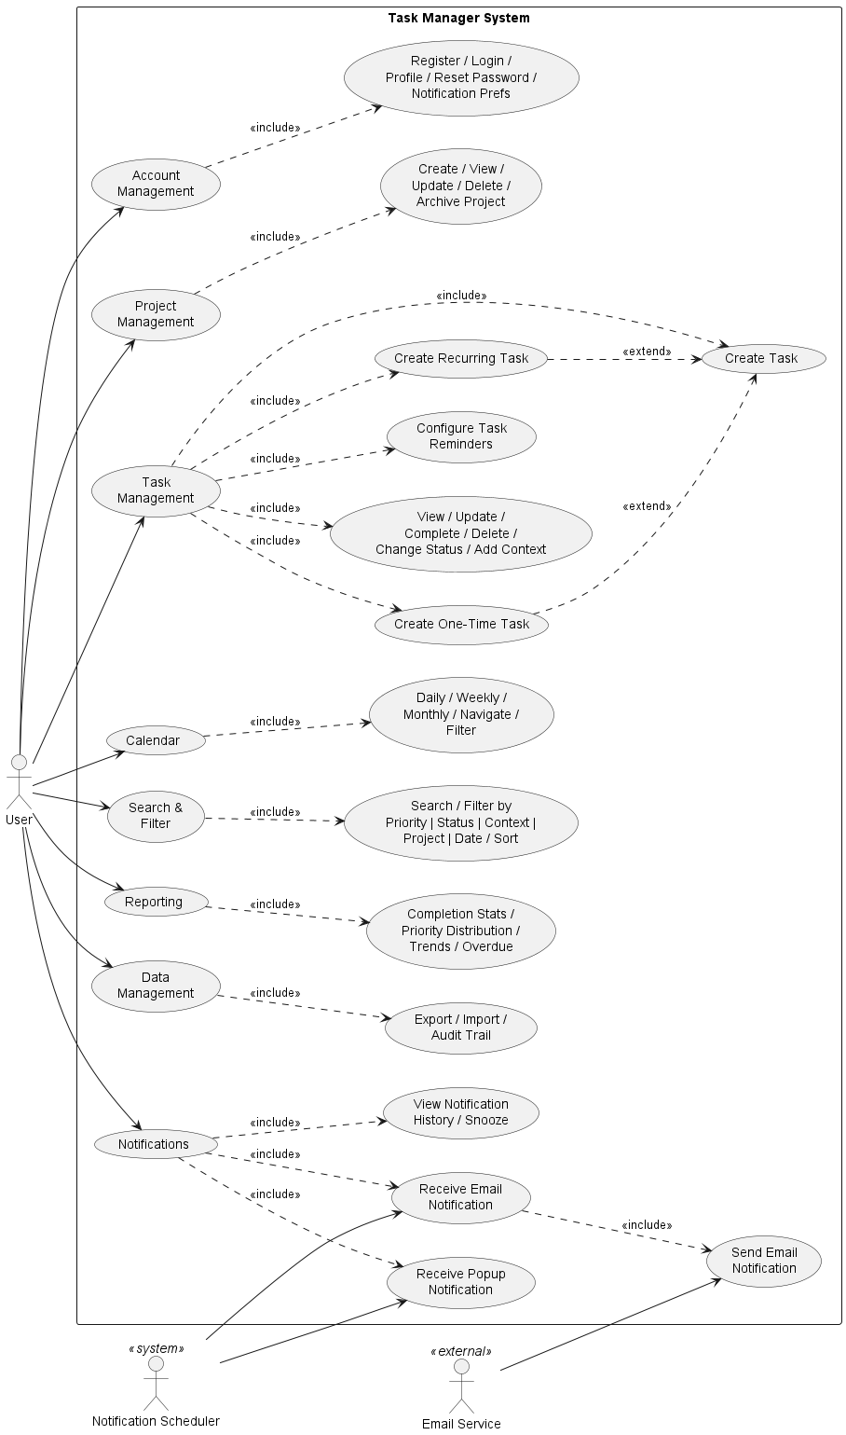 3.4.3 Object Model
Class Diagram Description
The system follows object-oriented principles with clear separation of concerns through layered architecture:
Core Domain Classes:
User
  - Attributes: userId (Long), username (String), email (String), passwordHash (String), firstName (String), lastName (String), createdAt (LocalDateTime), lastLogin (LocalDateTime)
  - Associations: One-to-Many with Project, One-to-One with NotificationPreferences
  - Methods: updateProfile(), changePassword(), getActiveProjects()
Project
  - Attributes: projectId (Long), name (String), description (String), colorCode (String), createdAt (LocalDateTime), archived (Boolean)
  - Associations: Many-to-One with User, One-to-Many with Task
  - Methods: calculateCompletionPercentage(), addTask(), removeTask(), archive()
Abstract Task (Base Class)
  - Attributes: taskId (Long), title (String), description (String), dueDate (LocalDateTime), priority (PriorityEnum: A/B/C/D), status (StatusEnum: NOT_STARTED/IN_PROGRESS/COMPLETED/DEFERRED), createdAt (LocalDateTime), completedAt (LocalDateTime), estimatedDuration (Integer)
  - Associations: Many-to-One with Project, One-to-Many with Context, One-to-Many with TaskComment, One-to-Many with Reminder
  - Methods: markComplete(), updateStatus(), addComment(), isOverdue()
  - Pattern: Abstract base class demonstrating inheritance
OneTimeTask (extends Task)
  - Attributes: None additional
  - Methods: Inherits all from Task
  - Description: Represents tasks that occur exactly once
RecurringTask (extends Task)
  - Attributes: recurrencePattern (RecurrencePattern), startDate (LocalDate), endDate (LocalDate), parentTaskId (Long)
  - Associations: One-to-Many with TaskInstance
  - Methods: generateInstances(), skipOccurrence(), modifyInstance()
  - Pattern: Template Method pattern for task instance generation
RecurrencePattern
  - Attributes: patternId (Long), frequency (FrequencyEnum: DAILY/WEEKLY/MONTHLY/CUSTOM), interval (Integer), daysOfWeek (Set<DayOfWeek>), dayOfMonth (Integer), endCondition (EndConditionEnum: NEVER/AFTER_OCCURRENCES/BY_DATE), occurrenceCount (Integer)
  - Methods: calculateNextOccurrence(), validatePattern()
  - Pattern: Strategy pattern for different recurrence rules
TaskInstance
  - Attributes: instanceId (Long), instanceDate (LocalDate), overridden (Boolean)
  - Associations: Many-to-One with RecurringTask
  - Methods: overrideForInstance()
  - Description: Represents individual occurrence of recurring task
Context
  - Attributes: contextId (Long), name (String), icon (String)
  - Associations: Many-to-Many with Task
  - Methods: None (Value Object)
  - Description: Represents situational tags (@home, @office, etc.)
TaskComment
  - Attributes: commentId (Long), content (String), createdAt (LocalDateTime)
  - Associations: Many-to-One with Task, Many-to-One with User
  - Methods: None
Reminder
  - Attributes: reminderId (Long), reminderType (ReminderTypeEnum: EMAIL/POPUP), leadTime (Duration), sentAt (LocalDateTime), acknowledged (Boolean)
  - Associations: Many-to-One with Task
  - Methods: send(), acknowledge(), snooze()
  - Pattern: Observer pattern for notification triggering
NotificationPreferences
  - Attributes: preferenceId (Long), emailEnabled (Boolean), popupEnabled (Boolean), defaultLeadTime (Duration), quietHoursStart (LocalTime), quietHoursEnd (LocalTime)
  - Associations: One-to-One with User
  - Methods: updatePreferences(), isInQuietHours()
Calendar (Interface)
  - Methods: renderView(), getTasksForPeriod()
  - Pattern: Strategy pattern interface for calendar views
DailyCalendarView (implements Calendar)
  - Attributes: viewDate (LocalDate)
  - Methods: renderView(), getTasksForPeriod()
WeeklyCalendarView (implements Calendar)
  - Attributes: weekStartDate (LocalDate)
  - Methods: renderView(), getTasksForPeriod()
MonthlyCalendarView (implements Calendar)
  - Attributes: month (YearMonth)
  - Methods: renderView(), getTasksForPeriod()
AuditLog
  - Attributes: logId (Long), userId (Long), action (String), entityType (String), entityId (Long), timestamp (LocalDateTime), changes (String)
  - Methods: None
  - Description: Tracks all modifications for traceability
Enumerations:
PriorityEnum: A, B, C, D
StatusEnum: NOT_STARTED, IN_PROGRESS, COMPLETED, DEFERRED
FrequencyEnum: DAILY, WEEKLY, MONTHLY, CUSTOM
EndConditionEnum: NEVER, AFTER_OCCURRENCES, BY_DATE
ReminderTypeEnum: EMAIL, POPUP
Design Patterns Demonstrated:
Inheritance: Task → OneTimeTask, RecurringTask
Strategy Pattern: Calendar interface with DailyCalendarView, WeeklyCalendarView, MonthlyCalendarView implementations
Observer Pattern: Reminder system for notifications
Factory Pattern: TaskFactory for creating appropriate task types
Repository Pattern: Data access layer abstraction
Composition: Project contains Tasks, Task contains Reminders
Key Relationships:
User (1) → (*) Project: One user has many projects
Project (1) → (*) Task: One project contains many tasks
Task () → () Context: Many-to-many relationship for flexible tagging
RecurringTask (1) → (*) TaskInstance: One recurring task generates many instances
Task (1) → (*) Reminder: One task can have multiple reminders
Task (1) → (*) TaskComment: One task can have multiple comments

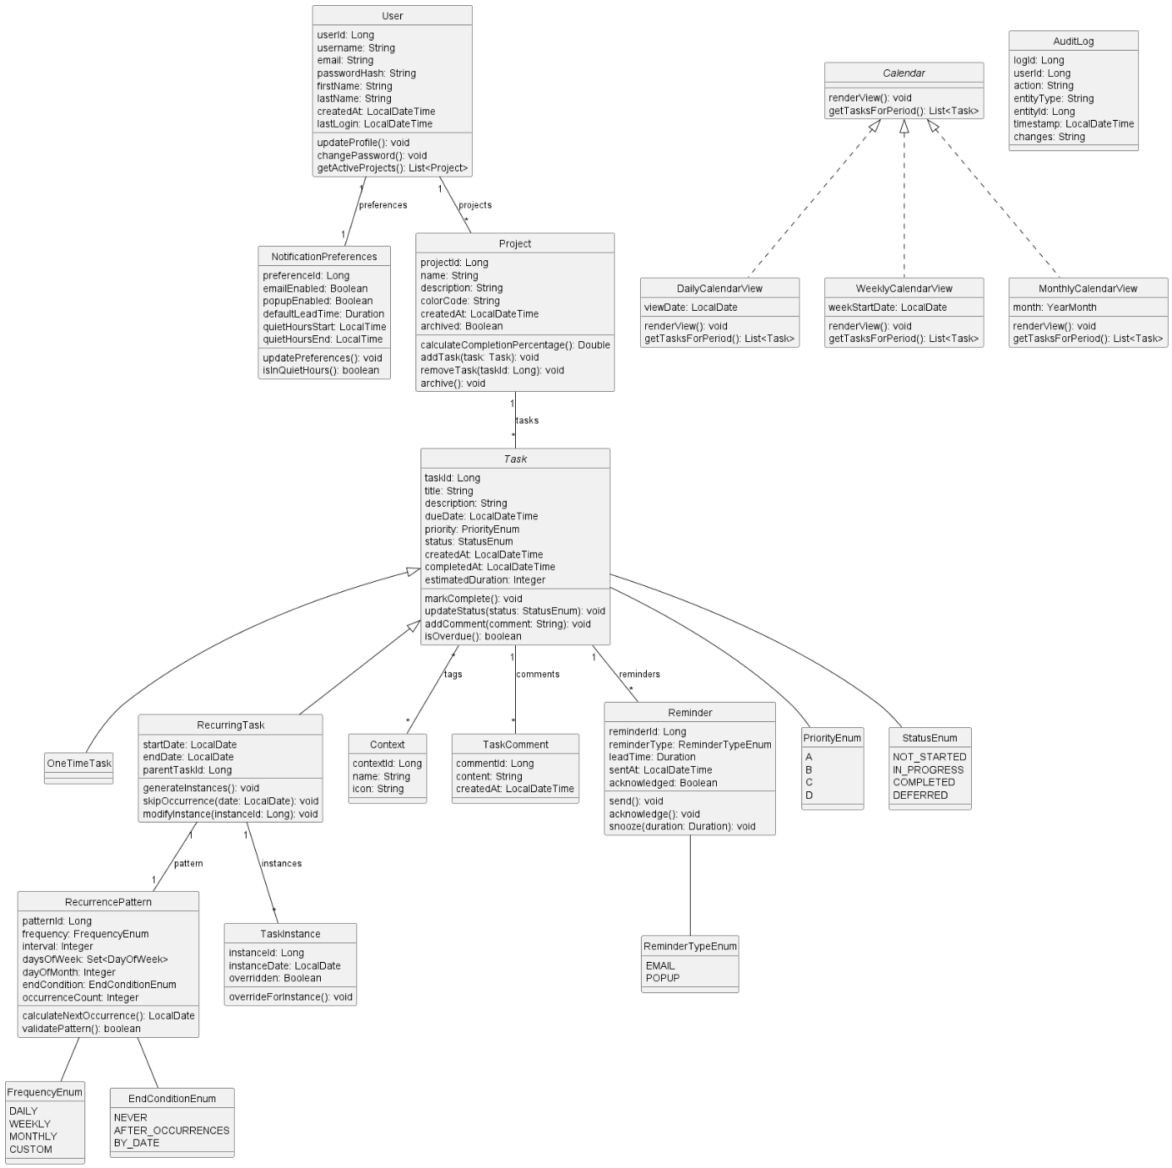

3.4.4 Dynamic Model
Sequence Diagram: Create Recurring Task
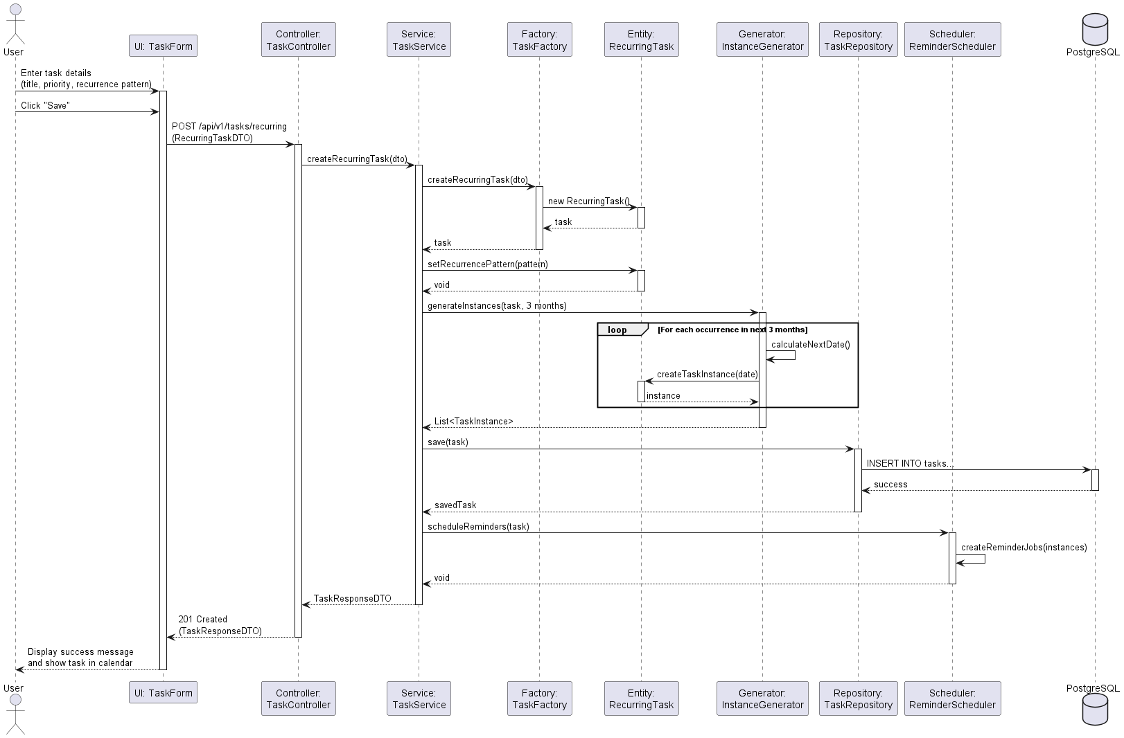

Sequence Diagram: Send Email Reminder
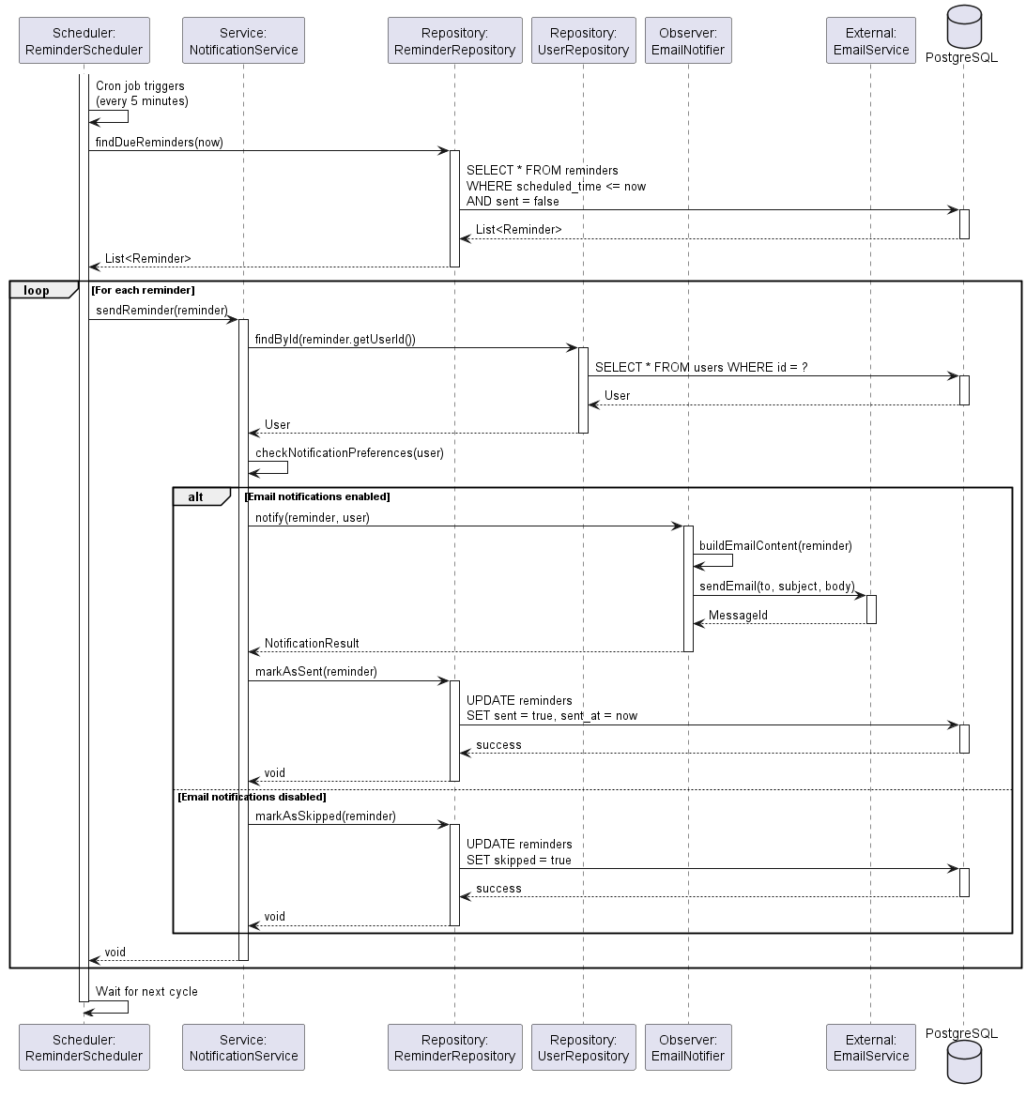

State Diagram: Task Lifecycle
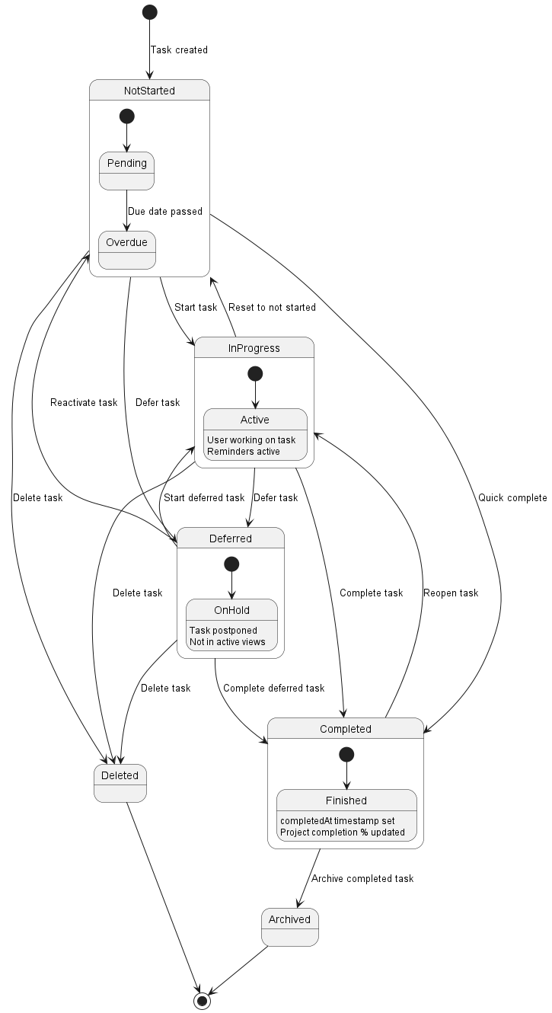

Activity Diagram: Filter and Sort Tasks
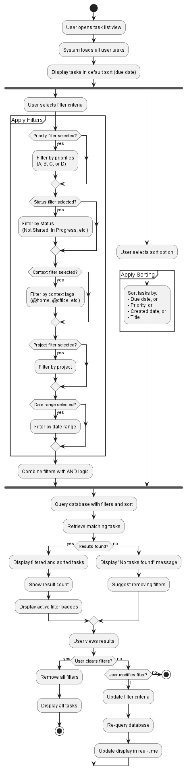

3.4.5 User Interface and Mock-ups
UI Structure Overview
The Smart Personal Task Manager follows a modern single-page application design with consistent navigation and responsive layouts.
Main UI Components:
- Navigation Bar (Top)
  - Logo and application name
  - Main navigation links: Dashboard, Projects, Calendar, Reports
  - Search bar
  - User profile menu (Settings, Logout)
  - Notification bell icon with badge
- Left Sidebar (Collapsible)
  - Quick filters: Today, This Week, Priority A, Overdue
  - Project list with task counts
  - Context tag cloud
  - "+ New Project" button
- Main Content Area
  - Dynamic view based on selected navigation
  - Breadcrumb navigation
  - View-specific toolbars and actions
- Right Panel (Contextual)
  - Task detail view when task selected
  - Filter panel when filtering active

Mock-up Descriptions
Mock-up 1: Dashboard View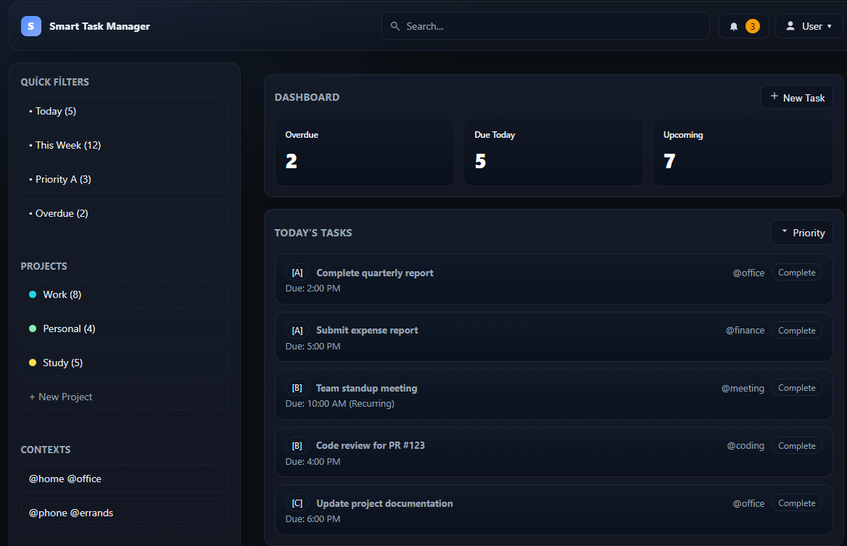

Key Features:
- Overview cards showing task counts by status
- Priority-based color coding (Red: A, Orange: B, Yellow: C, Green: D)
- Context tags displayed as chips
- Quick complete button for each task
- Recurring task indicator
- Responsive grid layout

Mock-up 2: Weekly Calendar View
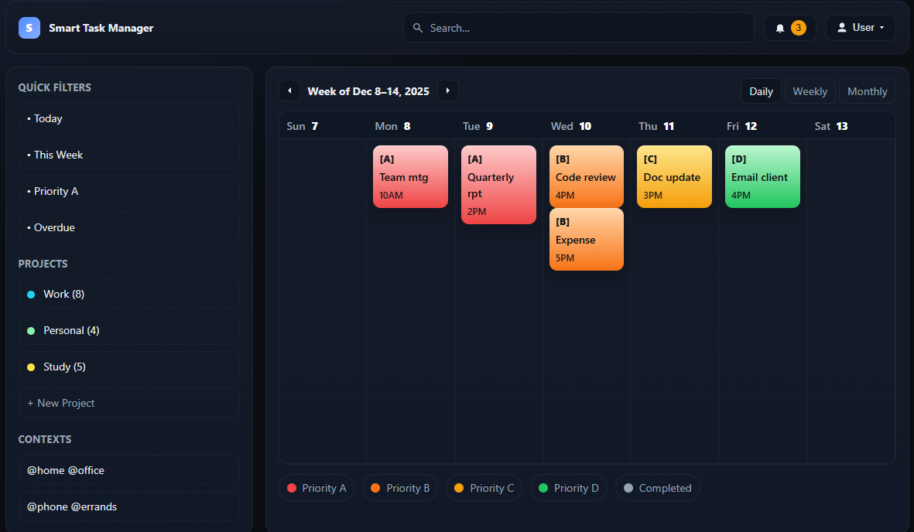
Key Features:
- Seven-day grid layout
- Color-coded task blocks by priority
- Task title and time displayed in cells
- Navigation arrows for previous/next week
- View switcher (Daily/Weekly/Monthly)
- Legend showing priority colors
- Today's date highlighted
- Drag-and-drop support for rescheduling

Mock-up 3: Task Creation Dialog
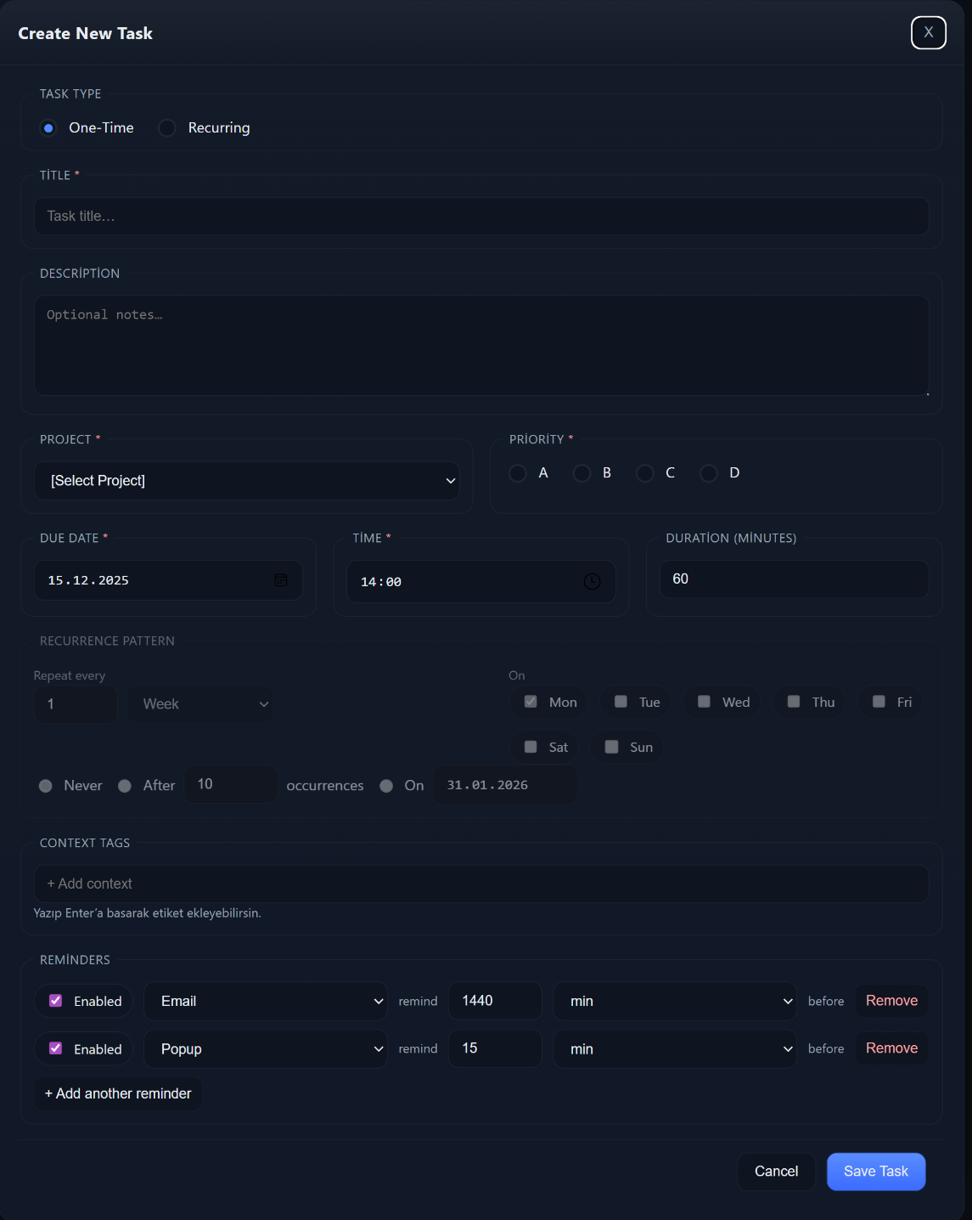
Key Features:
- Toggle between one-time and recurring task types
- Required fields marked with asterisk
- Intuitive date and time pickers
- Visual priority selector with radio buttons
- Flexible recurrence configuration with day-of-week selection
- Multiple end condition options
- Context tag management with autocomplete
- Multiple reminder configuration
- Clear cancel and save actions
Mock-up 4: Task Detail View (Right Panel)
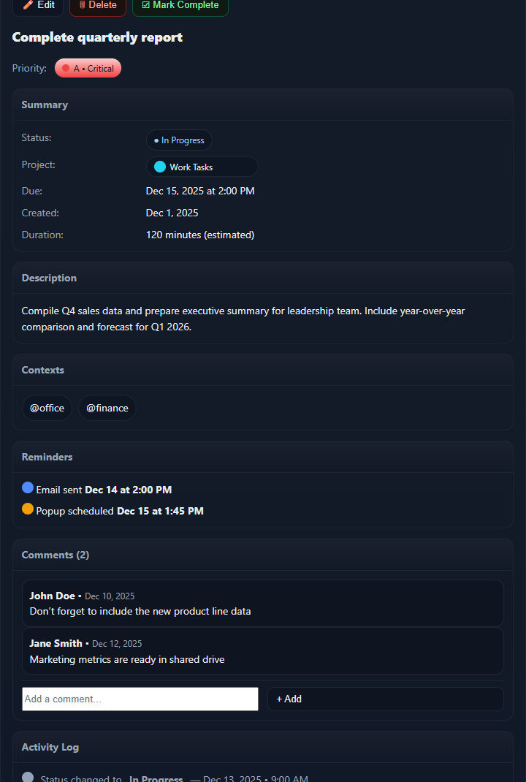
Key Features:
- Comprehensive task information display
- Quick action buttons (Edit, Delete, Complete)
- Status and project indicators
- Comments section for collaboration
- Activity log for audit trail
- Reminder status display
- Context tags
- Estimated duration
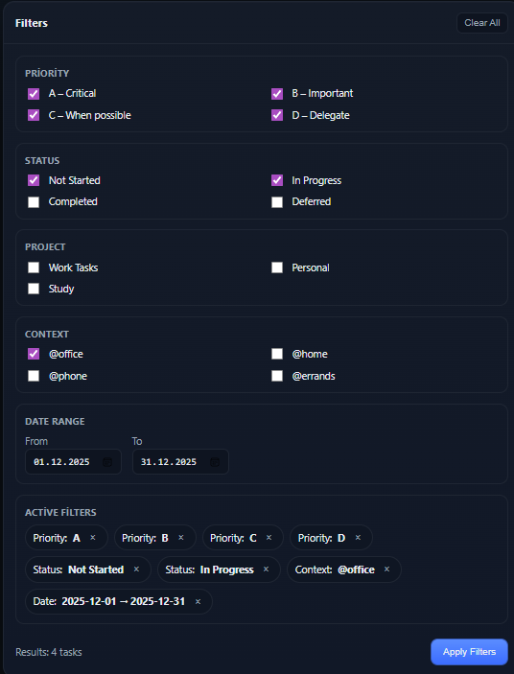
Key Features:
- Multiple filter categories
- Checkbox selection for easy toggling
- Date range picker
- Active filter chips with remove option
- Clear all filters button
- Result count display
- Apply button to confirm selections
Navigation Flow
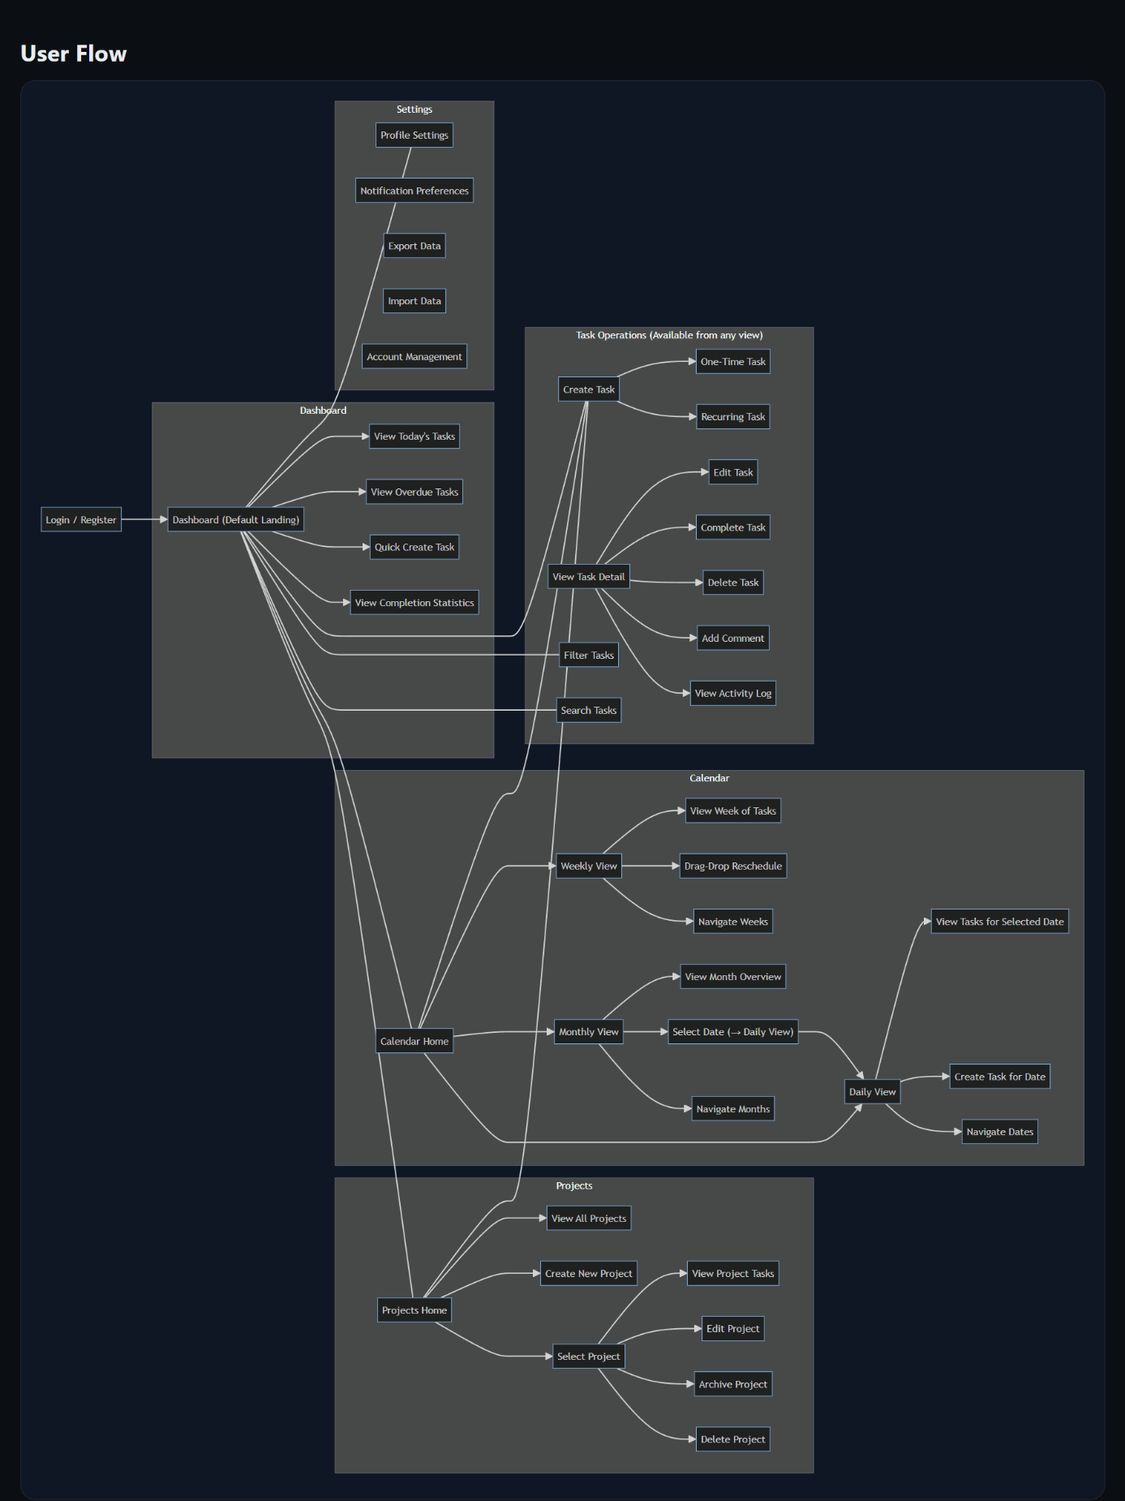

4. Glossary of Terms
Term | Definition
Archive | Moving a project or task to inactive status without deletion, preserving for historical reference
Audit Trail | Chronological record of all changes made to tasks and projects, including user and timestamp
Authentication | Process of verifying user identity through credentials (email/username and password)
Bcrypt | Cryptographic hash function used for securely storing passwords
Business Hours | Operational timeframe for the system, defined as 6:00 AM to 10:00 PM
Calendar View | Visual representation of tasks distributed across time (daily, weekly, or monthly layout)
Context | Situational or environmental tag applied to tasks (e.g., @home, @office, @phone, @errands) indicating where or when task can be completed CORS (Cross-Origin Resource Sharing)
CORS (Cross-Origin Resource Sharing) | Security mechanism allowing web applications to make requests to different domains
Cron Job | Time-based job scheduler for executing tasks at predetermined intervals
CRUD Operations | Create, Read, Update, Delete - fundamental database operations
Deferred Task | Task postponed to later time, removed from active task views
Domain Model | Conceptual representation of system entities and their relationships
DTO (Data Transfer Object) | Object that carries data between processes, particularly between application layers
Due Date | Deadline by which task should be completed
Estimated Duration | User's prediction of time required to complete task, measured in minutes
Franklin Covey Method | Time management methodology emphasizing priority-based organization using A/B/C/D categories
Frequency | How often recurring task repeats (daily, weekly, monthly, or custom)
GDPR (General Data Protection Regulation) | European regulation on data protection and privacy
Hibernate/JPA | Java Persistence API and ORM framework for database interaction
Instance (Task) | Single occurrence of recurring task with specific date
JWT (JSON Web Token) | Compact, URL-safe token format for authentication
Lead Time | Advance notice period for reminders (e.g., 1 hour, 1 day, 1 week before due date)
Mock-up | Visual representation of user interface design
Observer Pattern | Design pattern where objects (observers) are notified of changes to subject object
One-Time Task | Task that occurs exactly once on specified date
ORM (Object-Relational Mapping) | Programming technique for converting data between incompatible type systems
Override | Modifying single instance of recurring task without affecting other instances
Pagination | Dividing large result sets into discrete pages for better performance
PostgreSQL | Open-source relational database management system
Priority | Importance level of task using Franklin Covey A/B/C/D system:  - A: Critical/urgent requiring immediate attention  - B: Important with scheduled deadlines  - C: Completed when possible  - D: Can be delegated or deferred
Project | Container grouping related tasks under common theme or goal
React | JavaScript library for building user interfaces
Recurrence Pattern | Schedule defining how recurring task repeats (frequency, interval, days, end condition)
Recurring Task | Task that repeats on defined schedule automatically generating multiple instances
Reminder | Notification sent to user about upcoming or overdue task
Repository Pattern | Design pattern abstracting data access layer from business logic
RESTful API | Web API adhering to REST architectural constraints
Scenario | Narrative description of system usage illustrating how actors achieve goals
Session | Period of user interaction with system, maintained via JWT token
Snooze | Temporarily postponing notification for specified duration
Spring Boot | Java framework for building production-ready applications
Status | Current state of task:  - Not Started: Task created but work not begun  - In Progress: Task actively being worked on  - Completed: Task finished  - Deferred: Task postponed
Strategy Pattern | Design pattern enabling selection of algorithm at runtime (used for calendar views)
Subtask | Smaller task component of larger parent task
Task | Individual unit of work with attributes (title, description, due date, priority, context)
Task Instance | Single occurrence of recurring task
Template Method Pattern | Design pattern defining skeleton of algorithm, allowing subclasses to override steps
Timestamp | Date and time marker recording when action occurred
Token | Encrypted string authenticating user identity (JWT)
Traceability | Ability to link requirements to design elements and use cases
TypeScript | Typed superset of JavaScript compiling to plain JavaScript
UML (Unified Modeling Language) | Standardized modeling language for visualizing system design
Use Case | Description of system functionality from user perspective
WebSocket | Communication protocol providing full-duplex channels for real-time updates
WCAG (Web Content Accessibility Guidelines | Standards for making web content accessible to people with disabilities

5. Traceability
This section establishes traceability between functional requirements, use cases, and object model classes.

5.1 Requirements to Use Cases Traceability
Requirement ID | Requirement Description | Related Use Cases
FR-1 | User registration | UC-Register Account
FR-2 | User authentication | UC-Login
FR-3 | Password reset | UC-Reset Password
FR-4, FR-5 | Profile management | UC-Manage Profile
FR-6 | Session management | UC-Login
FR-7 | Create project | UC-Create Project
FR-8 | View projects | UC-View Projects
FR-9 | Update project | UC-Update Project
FR-10 | Delete project | UC-Delete Project
FR-11 | Archive project | UC-Archive Project
FR-12 | Project completion percentage | UC-View Project Statistics
FR-13 | Create one-time task | UC-Create One-Time Task
FR-14, FR-15 | Create recurring task | UC-1: Create Recurring Task
FR-16 | Edit task | UC-Update Task
FR-17 | Mark task complete | UC-Complete Task
FR-18 | Delete task | UC-Delete Task
FR-19 | Change task status | UC-Change Task Status
FR-20 | Assign task to project | UC-Create Task, UC-Update Task
FR-21 | Add context tags | UC-Add Task Context Tags
FR-22 | Task comments | UC-Add Task Comment
FR-23 | Task duration | UC-Create Task, UC-Update Task
FR-24 | Modify recurring instance | UC-1: Create Recurring Task (Extensions)
FR-25 | Skip recurring occurrence | UC-Skip Recurring Occurrence
FR-26 | Daily calendar view | UC-View Daily Calendar
FR-27 | Weekly calendar view | UC-2: View Weekly Calendar
FR-28 | Monthly calendar view | UC-View Monthly Calendar
FR-29 | Switch calendar views | UC-2: View Weekly Calendar
FR-30 | Highlight today | UC-View Daily Calendar, UC-2: View Weekly Calendar
FR-31 | Priority color coding | UC-2: View Weekly Calendar
FR-32 | Completion status display | UC-2: View Weekly Calendar
FR-33 | Navigate calendar | UC-Navigate Calendar
FR-34 | Jump to specific date | UC-Navigate Calendar
FR-35 | Task count per day | UC-View Monthly Calendar
FR-36, FR-37 | Send reminders | UC-3: Receive Email Notification, UC-Receive Popup Notification
FR-38 | Configure reminder preferences | UC-Configure Task Reminders
FR-39 | Overdue task notifications | UC-3: Receive Email Notification
FR-40 | Notification history | UC-View Notification History
FR-41 | Snooze notifications | UC-Snooze Notification
FR-42 | Multiple reminder times | UC-Configure Task Reminders
FR-43 | Search tasks | UC-Search Tasks
FR-44 | Filter by priority | UC-4: Filter Tasks by Priority
FR-45 | Filter by status | UC-Filter by Status
FR-46 | Filter by context | UC-Filter by Context
FR-47 | Filter by project | UC-Filter by Project
FR-48 | Filter by date range | UC-Filter by Date Range
FR-49 | Combine filters | UC-4: Filter Tasks by Priority
FR-50 | Sort tasks | UC-Sort Tasks
FR-51 | Real-time filter results | UC-4: Filter Tasks by Priority
FR-52 | Completion rate statistics | UC-View Completion Statistics
FR-53 | Priority distribution charts | UC-View Priority Distribution
FR-54 | Productivity trends | UC-View Productivity Trends
FR-55 | Overdue tasks count | UC-View Overdue Tasks
FR-56 | Completion history | UC-View Completion Statistics
FR-57 | Auto-save data | All use cases (implicit)
FR-58 | Export data | UC-5: Export Data
FR-59 | Import data | UC-Import Data
FR-60 | Audit trail | UC-View Audit Trail

5.2 Use Cases to Domain Classes Traceability
Use Case ID | Use Case Name | Related Domain Classes
UC-1 | Create Recurring Task | RecurringTask, RecurrencePattern, TaskInstance, Project, Context, Reminder
UC-2 | View Weekly Calendar | WeeklyCalendarView (Strategy), Task, OneTimeTask, RecurringTask, TaskInstance
UC-3 | Receive Email Notification | Reminder, User, NotificationPreferences, Task (Observer pattern)
UC-4 | Filter Tasks by Priority | Task, OneTimeTask, RecurringTask, PriorityEnum
UC-5 | Export Data | User, Project, Task, OneTimeTask, RecurringTask, Context, AuditLog
UC-Register Account | Register Account | User, NotificationPreferences
UC-Login | Login | User
UC-Create Project | Create Project | Project, User
UC-View Projects | View Projects | Project, User, Task
UC-Create One-Time Task | Create One-Time Task | OneTimeTask, Project, Context, Reminder
UC-Complete Task | Complete Task | Task, OneTimeTask, RecurringTask, TaskInstance, AuditLog
UC-View Daily Calendar | View Daily Calendar | DailyCalendarView (Strategy), Task
UC-View Monthly Calendar | View Monthly Calendar | MonthlyCalendarView (Strategy), Task
UC-Add Task Comment | Add Task Comment | TaskComment, Task, User
UC-View Notification History | View Notification History | Reminder, User

5.3 Requirements to Object Model Traceability
Domain Class | Supports Requirements
User | FR-1, FR-2, FR-3, FR-4, FR-5, FR-6, NFR-34, NFR-48, NFR-49, NFR-50
NotificationPreferences | FR-38, FR-41, NFR-52
Project | FR-7, FR-8, FR-9, FR-10, FR-11, FR-12
Task (Abstract) | FR-13, FR-14, FR-16, FR-17, FR-18, FR-19, FR-20, FR-22, FR-23, NFR-12
OneTimeTask | FR-13
RecurringTask | FR-14, FR-15, FR-24, FR-25, NFR-21
RecurrencePattern | FR-14, FR-15
TaskInstance | FR-15, FR-24, FR-25
Context | FR-21, FR-46
TaskComment | FR-22
Reminder | FR-36, FR-37, FR-38, FR-39, FR-40, FR-41, FR-42, NFR-22
Calendar (Interface) | FR-26, FR-27, FR-28, FR-29, NFR-36 (Strategy Pattern)
DailyCalendarView | FR-26, FR-30, NFR-17
WeeklyCalendarView | FR-27, FR-30, FR-31, FR-32, FR-33, NFR-17
MonthlyCalendarView | FR-28, FR-30, FR-35, NFR-17
AuditLog | FR-60, NFR-14
PriorityEnum | FR-31, FR-44, FR-53
StatusEnum | FR-19, FR-45, FR-55
FrequencyEnum | FR-14, FR-15
ReminderTypeEnum | FR-36, FR-37

5.4 Scenarios to Requirements Traceability
Scenario | Requirements Validated
Scenario 1: New User Registration and First Task Creation | FR-1, FR-2, FR-6, FR-7, FR-13, FR-20, FR-21, FR-36, FR-57, NFR-1, NFR-2, NFR-34
Scenario 2: Creating and Managing Recurring Task | FR-14, FR-15, FR-16, FR-24, FR-36, FR-57, NFR-2, NFR-21
Scenario 3: Daily Task Management Workflow | FR-17, FR-19, FR-26, FR-37, FR-43, FR-44, FR-45, FR-46, FR-50, FR-52, FR-55, NFR-2, NFR-16
Scenario 4: Using Multiple Calendar Views | FR-26, FR-27, FR-28, FR-29, FR-30, FR-33, FR-34, FR-35, NFR-17
Scenario 5: Email Reminder and Task Completion | FR-17, FR-36, FR-39, FR-40, FR-57, FR-60, NFR-2, NFR-22

5.5 Non-Functional Requirements to System Components
NFR Category | Requirements | Related System Components
Usability | NFR-1 to NFR-8 | React Frontend, UI Components, User Interface Layer
Reliability | NFR-9 to NFR-15 | Spring Boot Backend, PostgreSQL Database, Exception Handling, Transaction Management
Performance | NFR-16 to NFR-22 | Database Indexing, Query Optimization, Caching Layer, Background Job Scheduler
Supportability | NFR-23 to NFR-28 | Swagger Documentation, Logging Framework (SLF4J/Logback), JUnit/Mockito Tests, Database Migration Scripts
Implementation | NFR-29 to NFR-36 | Java 17 + Spring Boot 3.x, React 18 + TypeScript, PostgreSQL 15, Hibernate/JPA, JWT Authentication, Maven
Interface | NFR-37 to NFR-42 | REST Controllers, WebSocket Configuration, CORS Configuration, Health Check Endpoints
Packaging | NFR-43 to NFR-47 | Maven Build, React Production Build, Docker Compose, Spring Profiles
Legal | NFR-48 to NFR-52 | BCrypt Password Encoder, GDPR Compliance Module, Privacy Policy Service, Terms of Service

